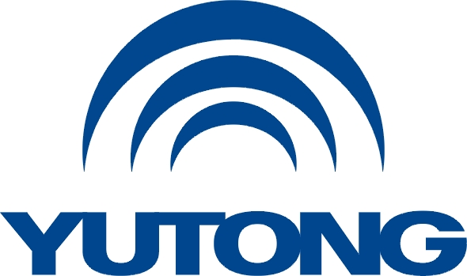

**Media Kit**

**For the Busworld Europe 2025**

**Yutong Service**

Yutong Bus Co., Ltd.

October, 2025

**Yutong Service**

To address industry-wide pain points like “Slow Response to Market Demand”, “Untimely Supply of Parts”, “Weak Intelligent Service Capability” and “Insufficient Professional Capacity for New Energy Vehicles”, while continuously enhancing Yutong’s service capabilities and optimizing customer experience—we aim to establish “Yutong’s after-sales service leadership” as a key value perception among customers. In 2025, Yutong has launched the Service Brand “EnRoute+” to further boost customer loyalty, enhance vehicle premium, and strengthen brand empowerment.

EnRoute+ is designed for comprehensive operational scenarios, built on the principle of “end-to-end support by expertise”. Backed by Yutong’s reliable service, it ensures high vehicle uptime, efficient performance, and stable operation for maximum customer value. The “+” symbol (representing upgrade and enhancement) conveys the iterative concept of “digital value-added empowerment and continuous strength upgrading,” establishing a full-scenario, scalable and strong link relationship between operation+ service. Full lifecycle operational solution is built on eight fundamental service commitments:

Manufacturer Direct Service: Yutong employees stay on site 365 days a year, providing customers with professional, efficient, reliable and attentive full-cycle service.

Rapid Response & Efficient Solutions: Customer can directly contact Yutong via Link+ or service hotline with one click; Yutong also provides emergency rescue services.

100% Transparent Service Process: The Link+ platform ensures 100% transparency of key service process nodes and one-click evaluation of service results.

100% Genuine Parts Assurance: Central warehouse + forward warehouse 2-level parts reserve system can respond quickly and provide genuine parts with warranty and worry-free supply for 15 years.

Dedicated Support for Major Events and Competitions: Establish a dedicated service team, formulate special support plans and emergency mechanisms to ensure that everything goes without a hitch.

Customized and Managed Service Package: Deliver tailored service package solutions, implement preventive maintenance, increase vehicle uptime, reduce customer costs, and provide seamless support.

Full-cycle Service Support: Yutong innovatively proposes a considerate service standard for new energy vehicles to offer personalized services to customers.

Customized and Managed Service Package: Dedicated service team for new energy vehicle customers.

Yutong is committed to enhancing its service and parts supply system, building a customer-centric after-sales network. Through direct service and third-party service, we meet diverse market and customer needs to continuously improve service quality. Yutong provides instant online services to customers, promptly addresses their needs, and offers round-the-clock vehicle repair support.